CPE301 – SPRING 2019

Design Assignment 2B

Student Name: Kyungseo Yun

Student #: 2001091216

Student Email: yunk93@unlv.nevada.edu

Primary Github address: <https://github.com/biscuit0x/submission_yun.git>

Directory: submission_yun/DesignAssignments/DA2B/

**1. COMPONENTS**

ATMEGA328, multi-function shield, breadboard, wires

**2. ASM CODE**

.ORG 0 ;location of reset

JMP MAIN

.ORG 0x02 ;location of external interrupt INT0

JMP LED_ON

MAIN:

LDI R20, HIGH(RAMEND) ;stack initialization

OUT SPH, R20

LDI R20, LOW(RAMEND)

OUT SPL, R20

CLR R19

STS TCCR1A, R19

STS TCCR1B, R19

LDI R20, 0X02 ;set INT0 falling edge triggered

STS EICRA, R20

SBI PORTB, 2 ;set PB2 (led off)

SBI DDRB, 2 ;PB2 as output

SBI PORTD, 2 ;PD2 pull-up activated

LDI R20, 1<<INT0

OUT EIMSK, R20 ;enable INT0

SEI ;enable interrupts

HERE : JMP HERE ;wait for INT0

LED_ON:

LDI R20, 0X05

STS TCCR1B, R20 ;prescaler=1024

CLR R20

STS TCNT1H, R20

STS TCNT1L, R20

CBI PORTB, 2

RCALL DELAY1

RETI

DELAY1:

LDS R19, TCNT1H ;load upper timer1

LDS R18, TCNT1L ;load lower timer1

CPI R19, 0X51 ;compare upper timer1 with 0x51

BRLO DELAY1 ;if lower than 0x51, wait more

DELAY2:

LDS R18, TCNT1L ;load lower timer1

CPI R18, 0X5C ;compare lower timer1 with 0x5c

BRLO DELAY2 ;if lower than 0x5C, wait more

SBI PORTB, 2 ;turn off led

RET

**2. C CODE VERIFICATION**

#include <avr/io.h>

#include <avr/interrupt.h>

int main()

{

PORTB = 1<<2; //set PB2 (led off)

DDRB = 1<<2; //PB2 as an output

PORTD = 1<<2; //PD2 pull-up activated

EICRA = 0X2; //make INT0 falling edge triggered

EIMSK = (1<<INT0); //enable external interrupts

sei (); //enable interrupts

while (1); //wait here

}

ISR (INT0_vect) //ISR for external interrupt 0

{

TCCR1A = 0;

TCCR1B = 5; //prescaler = 1024

TCNT1 = 0; //begin timer

PORTB ^= (1<<2); //turn on LED

while(TCNT1 < 20928); //count 1.333 sec

PORTB ^= (1<<2); //turn off LED

}

**3. SCHEMATIC**

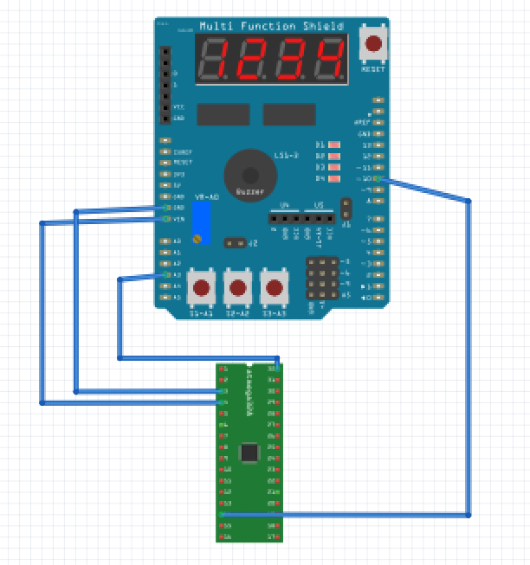

A3 => PD2 (INT0)

LED4 => PB2

**4. SIMULATION RESULT**

Led-on time (1.333s) :

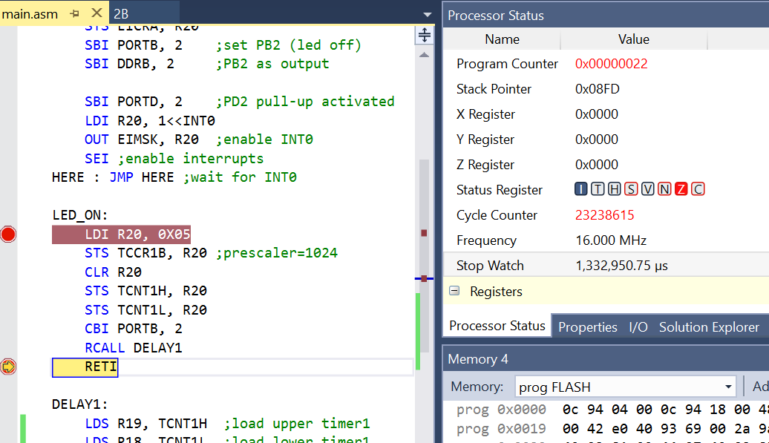

INT0 register : 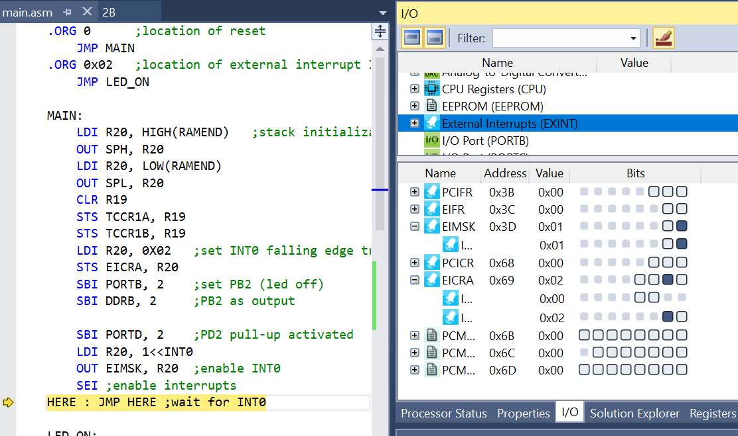

**5. PHOTO / VIDEO**

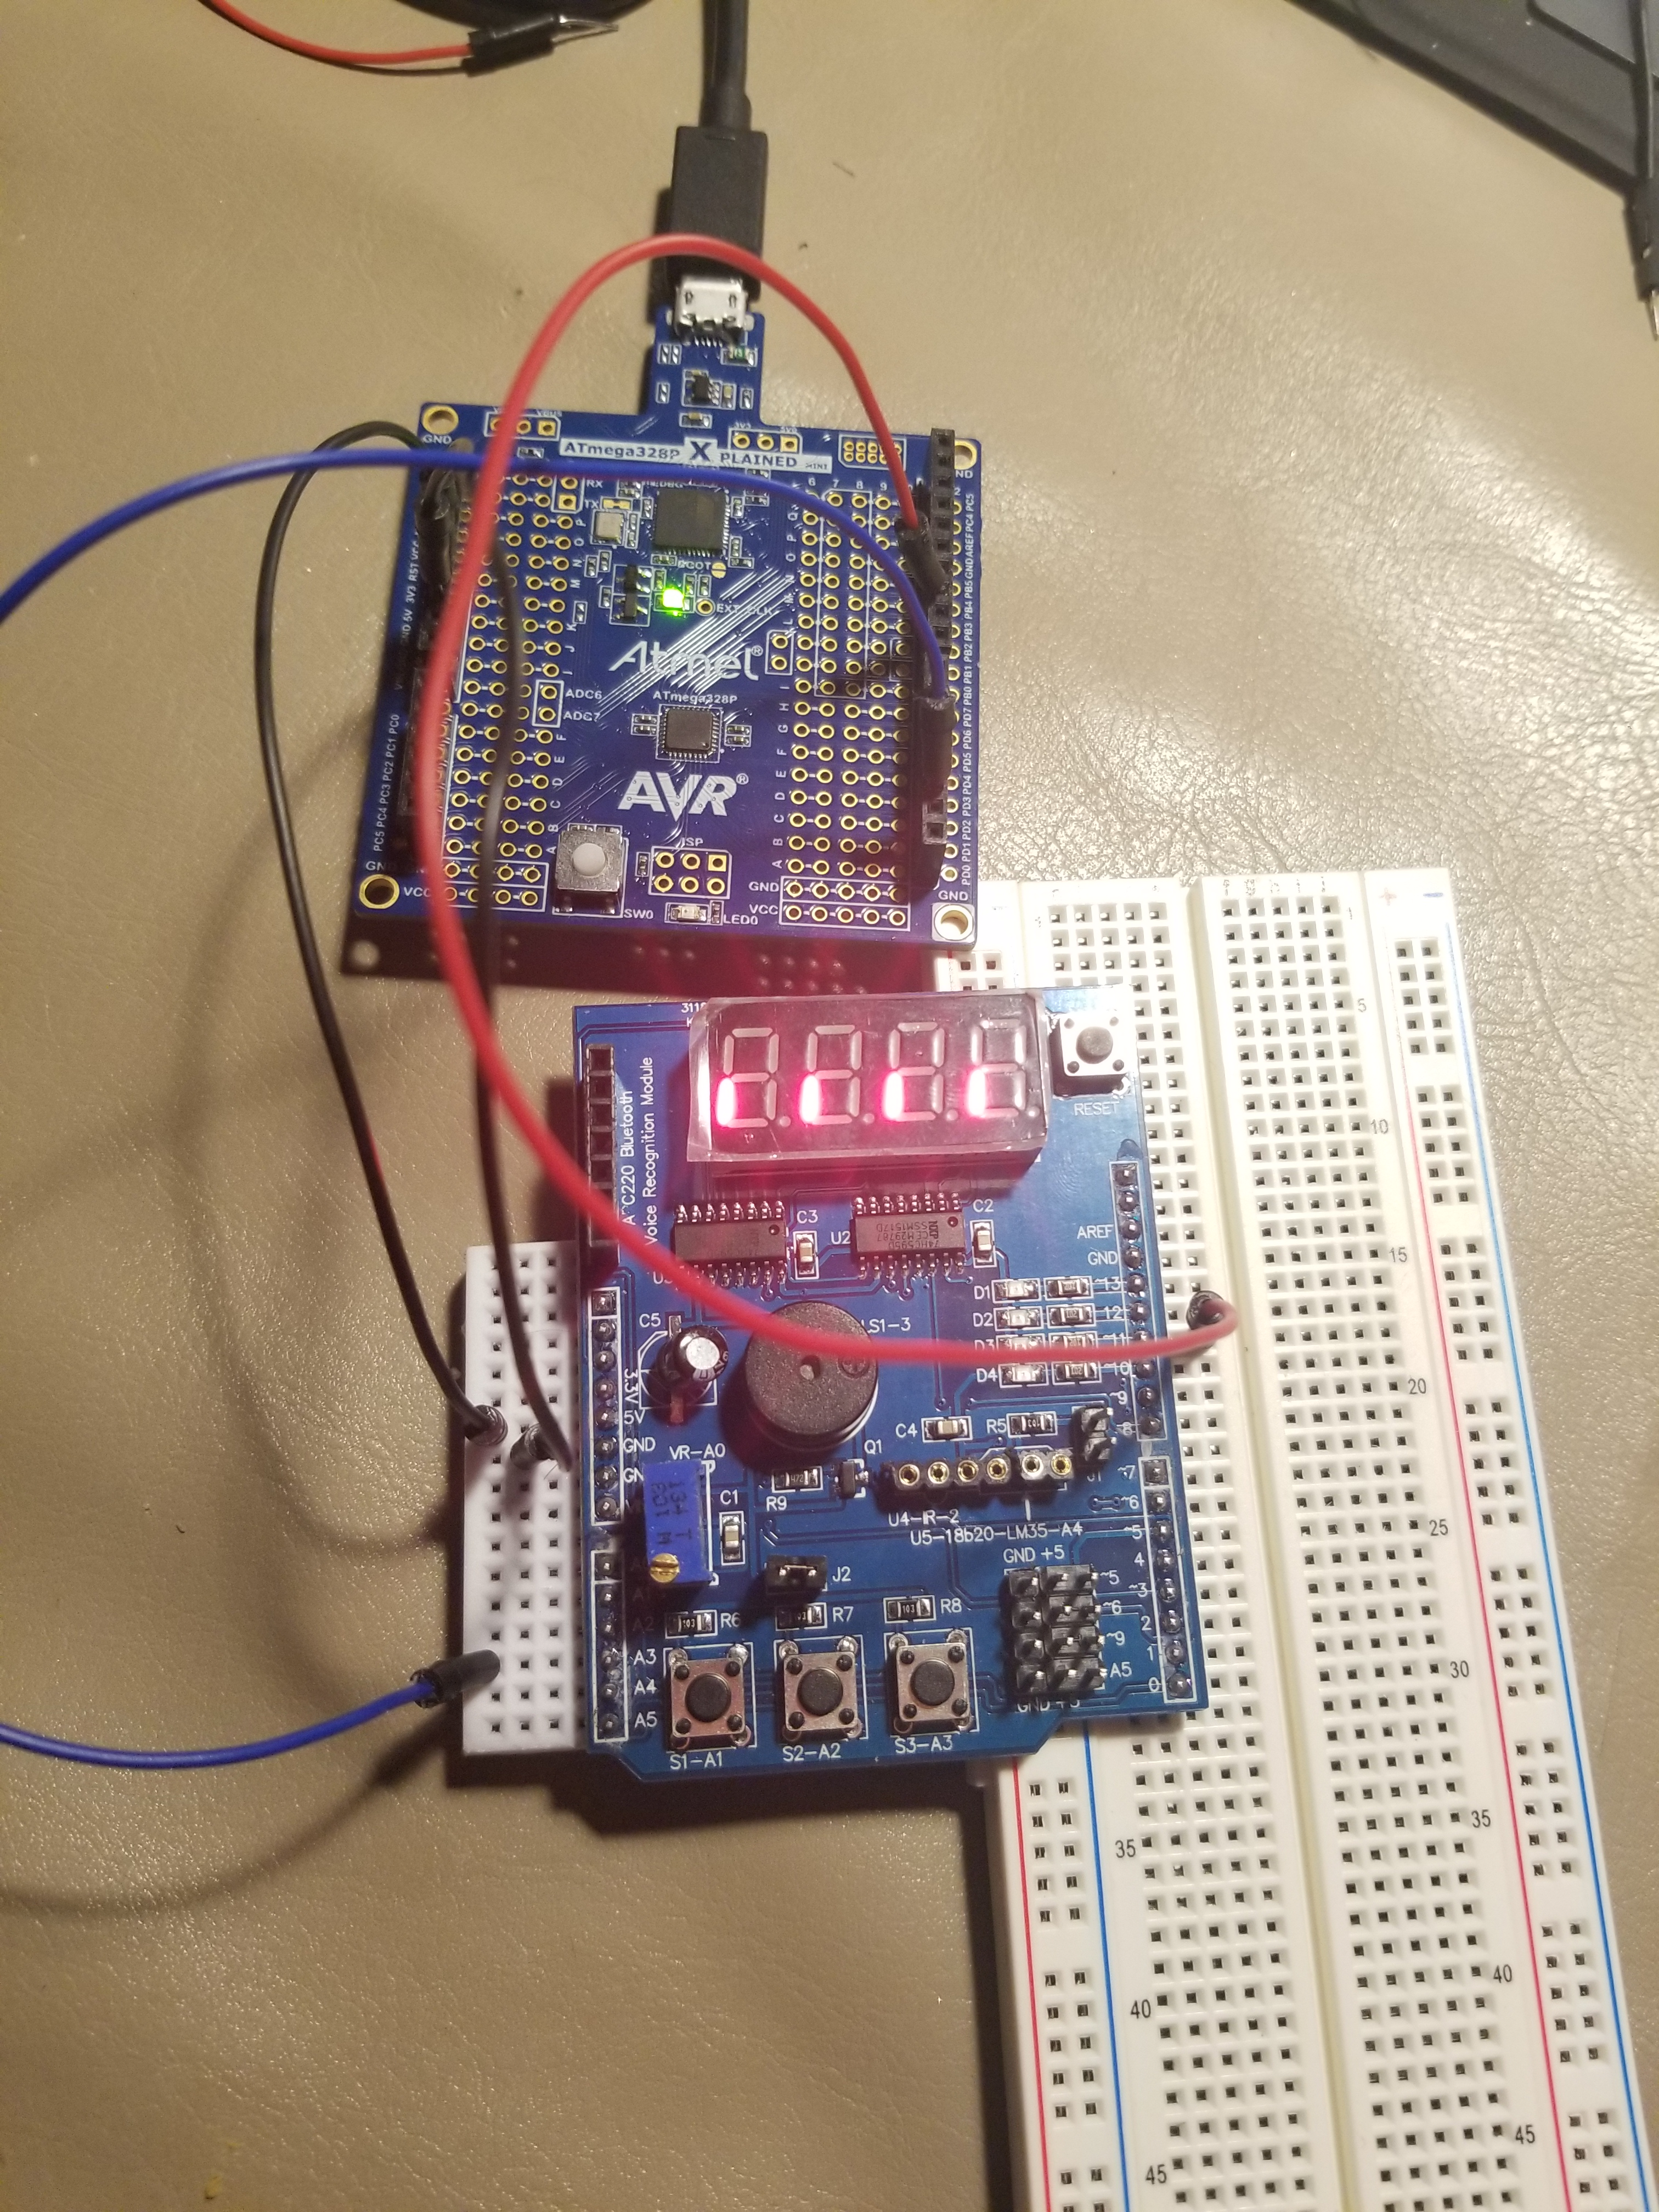

Video : https://youtu.be/YSwSmIy9Wo8

**6. GITHUB ADDRESS**

<https://github.com/biscuit0x/submission_yun/tree/master/DesignAssignments/DA2B>